# **Thirty-Second Annual Fall Institute on Estate Planning**

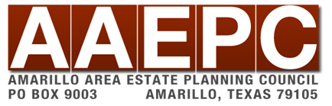

## Who we are

## The Amarillo Area Estate Planning Council is an association of attorneys, bank trust officers, certified public accountants, insurance professionals, financial advisors and associated professionals. The primary goal of the AAEPC is to provide our members with the latest trends, tools, and techniques in estate planning.

## Contact Us

Email: [aaepc1@gmail.com](mailto:aaepc1@gmail.com)

Web: [www.aaepc.org](http://www.aaepc.org)

# **Featured Speakers**

**Jovan Glasgow**, Renowned for his innovative PX3 Method, Jovan aligns personal and professional development with purpose. This method optimizes individual performance and fosters a unified, vibrant culture within organizations. For over a decade, Jovan has empowered Fortune 500 companies, crafting extraordinary teams committed to integrity and vitality. Ranked 2nd in Yahoo Finance's Top 10 Motivational Speakers and featured in Choice Point's Top 30 globally, Jovan's impact is indisputable. As a serial entrepreneur, strategist, and philanthropist, Jovan brings a wealth of knowledge to his programs. His expertise has been featured on NBC, NFL, and Yahoo Finance. Recognized as one of this generation's most dynamic minds, his influence extends far and wide. Jovan's mission is guided by his powerful motto: "Don't allow people to dilute you simply because they can't digest you." This philosophy underscores his commitment to helping others embrace their full potential without compromise.

**Tony Curatola**, is the Joseph F. Ford Professor of Accounting and Tax at Drexel University in Philadelphia. Tony’s area of research is the taxation of individuals, small businesses owners, and retirement income. He has authored over 200 articles in his field and has completed sponsored research for external groups. His findings have appeared in media such as Forbes, The Washington Post, Wall Street Journal, and The New York Times. He is the former editor of the tax column for Strategic Finance, and the author of several interactive education courses for CeriFi (formerly Thomson Reuters courses). He holds a variety of leadership positions in accounting associations, including the Institute of Management Accountants. Dr. Curatola earned his B.S. in Accounting ’75 and MBA in Finance ‘77 from Drexel University, M.A. in Accounting ’79 from The Wharton School of the University of Pennsylvania, and Ph.D. in Accounting ‘81 from Texas A&M University.

**Dr. Holly Jeffreys**, founded the Panhandle Family Care in 2009 in efforts to improve access to healthcare for rural residents of the Texas Panhandle. She continues to provide access to both primary care and psychiatric care for 4 rural health clinics in the surrounding areas. Holly completed a Bachelor and Master of Science in Nursing from West Texas A&M University and a Doctorate in Nursing Practice from the University of Texas Health Science Medical Center. Holly is a licensed EMT, RN, and APRN and Board certified as a Family Nurse Practitioner, Psychiatric Mental Health Nurse Practitioner, and Rural Health Clinic Professional. Holly currently serves on the leadership team for WTAMU in her role as the Dean for the College of Nursing and Health Sciences. Holly currently serves as the Board President for Bushland ISD as well as the Texas Board of Nursing advisory board, Northwest Texas Small Business Development Centers advisory board, Texas Clinical Partners Accountable Care Organization board of directors, Harrington Cancer & Health Foundation board of directors, and the Texas Lt. Governors’ Advisory Board. Holly has been named Texas Panhandle Small Businessperson of the Year by U.S. Small Business Administration, Texas Nurse Practitioner of the Year by Texas Nurse Practitioners, and University of Texas Distinguished Alumni for which only 42 individuals have been awarded over the last 46 years. Holly has received the American Association of Nurse Practitioners State Excellence Award for Texas and the 25 Great Panhandle Nurse Award for the Texas Panhandle. Holly and her husband love spending time with their 4 children and grandchildren as well as extended church family and friends.

**Laura Reyher**, Laura Reyher joined the Department of Nursing in the College of Nursing and Health Sciences in 2016. She received her BSN in Nursing from West Texas State University in 1978, and a MSN in Comprehensive Nursing from West Texas A&M University in 2016. Laura teaches Introduction to Nursing Skills, Pathophysiology, and assists with clinical rotations in Populations/Community Health. Laura coauthored an article in Nurse Educator magazine, "An End-of-Life Care Interdisciplinary Team Clinical Simulation Model". She serves on numerous civic and health-related Boards and is a frequent speaker and expert panelist for issues related to healthy living and aging, health literacy for caregivers, community health, and end-of-life care.

**Christian Kelso,** is a Fellow of the American College of Trust and Estate Counsel and equity partner at the Dallas law firm of Farrow-Gillespie Heath Wilmoth LLP, where he practices in the areas of estate planning, wealth preservation and transfer, probate, tax, and transactional corporate law. His primary focus is finding practical solutions for families and businesses to avoid costly, and often heartbreaking disputes in both the courtroom and the living room. Outside of his legal practice, Christian teaches Estate Planning and Practice at Southern Methodist University’s Dedman School of Law. He also serves as facilitator and advisor for families wishing to implement family systems and governance. His book, Building Your Castle: A practical guide for protecting your legacy, helps families avoid the disastrous ‘Family Power Vacuum’ that occurs when a family patriarch becomes disabled or passes away. Christian received both his J.D. and LL.M. (Taxation) from Southern Methodist University. He speaks German fluently and lives in East Dallas with his wife and two children.

**Gary Stringer**, CFA, is Co-Founder of Stringer Asset Management, LLC (SAM). In his day-to-day role he serves as the President and Chief Investment Officer for the firm. Gary leads the portfolio management efforts for the Firm’s mutual funds and separately managed account portfolios. In this role, he works with the team to develop the Firm’s investment management process, strategic and tactical allocations, as well as security selection.

Prior to co-founding SAM in February 2013, Gary was a Managing Director at Morgan Keegan and Company, Inc. where he served as the Director of Investments for their Wealth Management Services division. Gary holds a Bachelor of Science degree in Marketing from the University of Maryland, as well as the Chartered Financial Analyst (CFA) designation, and is a member of the CFA Society of Memphis. He has also completed the Securities Industry Institute sponsored by the Securities Industry and Financial Markets Association and the Wharton School. Additionally, Mr. Stringer speaks at various industry conferences and is a frequent contributor to financial industry publications. When not working Gary likes to spend time with his large extended family, traveling internationally, attending live music events and almost anything that involves communing with nature and enjoying the great outdoors.

**Jonathan Bernstein,** CIMA® is Vice President and co-founder of Stringer Asset Management, LLC. In his day-to-day role, he serves as Sales & Marketing Director for the firm. Jonathan is responsible for leading the business development team, marketing and communication, as well as, working with key account partners and advisory teams. Prior to co-founding the firm., Jonathan was a Senior Vice President and the Director of Sales and Consulting at Morgan Keegan and Company, Inc. where he also built a successful retail advisory practice. He has spent most of his 30-plus year career working in practice and with financial advisors on effective communication, objective consulting and the pursuit of best practices to elevate the advisory business. He is an accomplished and dynamic presenter with extensive experience in communications, project & operations management and is a frequent contributor to financial industry publications and hosts the “Real Investment Insights Podcast”.

He earned a Bachelor of Science degree in Business Administration and Finance from Brooklyn College and holds the Certified Investment Management Analyst (CIMA®) designation. Jonathan currently lives in Katy, Texas with his wife Julie where they enjoy their time with extended family, friends and their three amazing children.

**Paul Hood,** is an author, speaker and consultant on tax, estate and charitable planning. A native of Louisiana (and a double LSU Tiger), Paul Hood obtained his undergraduate and law degrees from Louisiana State University and an LL.M. in taxation from Georgetown University Law Center before settling down to practice tax and estate planning law in the New Orleans area. Paul also spent almost six years running the planned giving operations for two higher ed state institution foundations. Paul has taught at the University of New Orleans, Northeastern University, The University of Toledo College of Law and Ohio Northern University Pettit College of Law. Paul has authored or co-authored nine books and over 200 professional articles on estate, charitable and tax planning and business valuation. Paul’s ninth book, Yours, Mine & Ours: Estate Planning for People in Blended or Step Families, is now out. His website is [www.paulhoodservices.com](http://www.paulhoodservices.com). A “recovering tax lawyer,” Paul is often quoted in publications that include Forbes magazine and The Wall Street Journal, and he’s been a frequent contributor to Leimberg Information Services, Inc. since its inception, Paul is a highly sought-after speaker and consultant because of his innate ability to see through the complexity and explain difficult and even boring subjects in understandable and entertaining language with his insightful and biting sense of humor, and he minces no words in doing so. Along the way, Paul’s been a father, husband, uncle, Godfather, lawyer, coach, mentor, trustee, member, director, president, partner, trust protector, director of planned giving, expert witness, agent, professor, judge, juror, respondent, and a defendant, and he uses his experience in these myriad roles to guide others.

# **Schedule**

## Wednesday October 30th

## **7:30 a.m. Attendee Arrival and Check-In**

## **Breakfast**

## **7:50 a.m. Welcome and Introductions**

## **8:10 a.m. Jovan Glasgow - Adaptive Leadership Mastery - Enhance Fluidity and Resilience through Organizational Transitions:**This program equips people leaders with the tools and mindset needed to navigate their teams through periods of organizational change with fluidity and resilience. Over the course of this two-part training, participants will explore the nature of both personal and organizational transitions, focusing on how these shifts impact team dynamics, individual behaviors, and leadership effectiveness. The first session covers transition challenges and typical team responses, while the second part delves into adaptive communication and management strategies to foster a flexible and resilient work environment. In this presentation, leaders will gain insights into the concept of fluidity in leadership, focusing on managing organizational transitions effectively. Attendees will learn practical strategies for guiding their teams through change with resilience and adaptability. Estate planning professionals will benefit by enhancing their leadership effectiveness, improving team dynamics, and managing transitions more constructively, both in their business and with clients.

## **10:10 a.m. Break**

## **10:30 a.m. Tony Curatola - Retirement Issues for Small Businesses in 2024-25:**Congress holds the view that individuals do not save adequately for retirement in part due to the failure of small businesses to sponsor retirement plans. To stimulate this area, the SECURE Act of 2019 and the SECURE 2.0 Act of 2022 are signed into law making changes and additions to the retirement area. These acts are intended to encourage small businesses to sponsor retirement plans, to encourage employees to participate, and to encourage employers to contribute to the plans. Small business consultant and tax professionals provide tax services to small business owners, and as such, they need to be aware of the opportunities that are available for the employees and small business owners to save for retirement. This area is even more challenging considering the enactment of the SECURE Act in 2019 and the SECURE 2.0 Act. In addition to these legislative acts, Treasury has provided some interpretations and clarifications to some of these tax provisions. Congress, on the other hand, has proposed legislation titled the SECURE 2.0 Technical Corrections Act.

## **11:30 a.m. Lunch – Hosted by West Texas A&M University Foundation**

## **12:30 p.m. Dr. Holly Jeffreys & Laura Reyher - Mental Health Panel:**This insightful presentation will delve into the intersection of mental health and estate planning. This session will cover an overview of common mental health conditions, where attendees will gain a foundational understanding of prevalent mental health issues and their potential impact on the decision-making processes. It will also help us recognize signs of mental health issues in clients and learn to identify early warning signs and symptoms of mental health challenges in your clients. The presentation will also provide practical tools, resources, and information that you can utilize to effectively manage and address mental health concerns in your professional practice.

## **1:30 p.m. Break**

## **1:45 p.m. Christian Kelso -** What to Discuss When Your Client Wants to Make Charitable Gifts: This presentation is designed to assist professionals as they help clients navigate tax and other issues in the context of charitable giving. The presentation will cover: distinguishing planned giving from other charitable giving, various tax implications donors should consider before making a gift, how a donor (and their advisor) might distinguish between more and less favorable donees. provides insight into the best assets to give to charity, examination of various methods for making charitable gifts comes after that, and looks at other factors which a charitably-minded client should be thinking about.

## **2:45 p.m. Gary Stringer and Jonathan Bernstein - Behavioral Finance From Theory To Practice:**Volatile markets coupled with 24/7 media coverage can create significant behavioral challenges for investors and financial professionals alike. Attitudes toward financial markets can distract from sound planning as emotions shift from fear of the market to fear of missing out (FOMO) and back again. Stringer Asset Management has spent decades developing their investment process in a way that addresses many of the behavioral biases that cause investors to fail. Gary Stringer will lead a compelling guided conversation, delving into some of the most common and egregious behavioral errors and outline some real techniques to address them.

## **3:45 p.m. Break**

## **3:55 p.m. Paul Hood - Yours, Mine and Ours – Planning for Blended Families:**Since the 2010 United States Census, blended families are officially the most common family form in the country. This obviously means that counseling clients who have blended families on the best planning strategies for their families is more important now than ever before. The problem is that many of the tried-and-true go-to dispositive schemes and techniques, e.g., joint tenancy, can be absolutely disastrous for blended families and often result in disinheriting either the children of the first partner to die, or that surviving partner-and the vexatious emotional litigation that too often ensues-including malpractice actions against their former estate planners. In particular, there are a number of important drafting considerations that estate planners need to know. Long-time LISI teammate, Paul Hood has been studying, thinking about, and speaking and writing about estate planning for blended families for more than 30 years. He has lots to say and brings specific drafting language to explain.

## **5:00 p.m. End of Day**

#### **General Information**

**Location -** The program will be held at the Amarillo Area Foundation Building 919 S Polk St, Amarillo - [Decoursey (West) Conference](https://maps.google.com/maps?hl=en&q=Decoursey%20%28West%29%20Conference&source=calendar) Room. Parking is available nearby, please see green areas highlighted below:

**Tuition/Registration –** Tuition includes admission to the morning and afternoon session, continental breakfast, catered luncheon, and refreshments at the breaks.

**Cancellation and Refund Policy –** Tuition will be refunded upon written cancellation received not later than October 16th, 2024. Cancellations received after October 16th, 2024 cannot be refunded. No refunds for no-shows.

**Early Registration** - Early registration is encouraged. Should seating become limited, priority will be given to AAEPC members and nonmembers will be accommodated on a first come, first served basis. Please register by October 23rd, 2024

**CLE/CE Credit -** Accreditation for this institute has been requested, but is subject to approval from: the State Bar of Texas; Texas State Board of Public Accountancy; Certified Financial Planners; and American Bankers Association for (CTFA and CRSP). Please see the bottom of our event page for CE that has been approved.

**Program Materials –** Each paid attendee will be able to access the speaker’s material, if any is provided, online.

**Course Objective –** These practical courses are designed to teach participants various tax and non-tax related issues that are involved in advising estate planning clients, and how to effectively resolve client concerns and meet the best needs of the client, including utilizing insurance to achieve the client’s goals. Participants should have a basic or beginning understanding of relevant tax concepts and principles of estate planning.

**We would like to thank our generous sponsors:**

**Platinum**



**Gold**

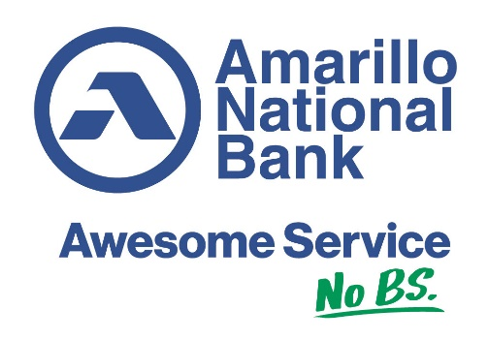

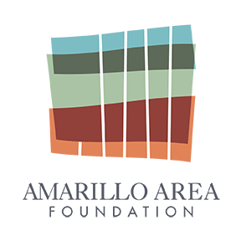



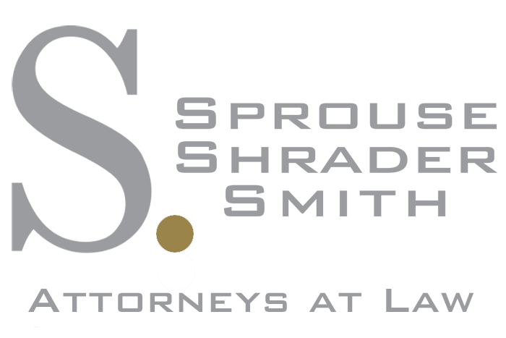

**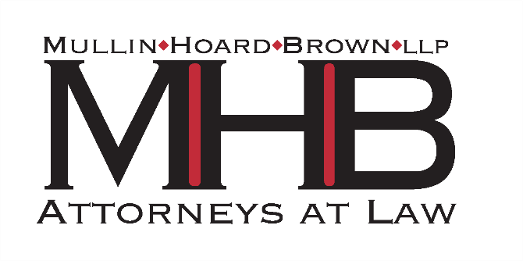****Silver**

**WE WOULD LIKE TO THANK THE AMARILLO AREA FOUNDATION FOR UNDERWRITING THE BEAUTIFUL NEW SPACE WE ARE IN FOR THIS INSTITUTE!**