# **Thirty-Third Annual Spring Institute on Estate Planning**



## Who we are

## The Amarillo Area Estate Planning Council is an association of attorneys, bank trust officers, certified public accountants, insurance professionals, financial advisors and associated professionals. The primary goal of the AAEPC is to provide our members with the latest trends, tools, and techniques in estate planning.

## Contact Us

Email: [aaepc1@gmail.com](mailto:aaepc1@gmail.com)

Web: [www.aaepc.org](http://www.aaepc.org)

# **Featured Speakers**

**Deanna Sullivan** is an internationally recognized speaker, author and trainer. Her most popular topics are in the areas of fraud, ethics, leadership and communications. She has a diverse background ranging from auditing and accounting to consulting and training. She was a partner in Arthur Andersen’s Risk Consulting Practice and earlier in her career, responsible for international and operational auditing at Enron Corp and Diamond Shamrock Corporation. Deanna is certified to teach ethics for Texas CPAs and is a Certified Ziglar Legacy Trainer, a certified DISC Behavioral Analyst and a Maxwell Leadership Certified Team Member. Speaking is a passion of Deanna's so when not traveling she teaches a Bible Study class at Second Baptist and is on the Speakers Committee for the Houston Livestock Show and Rodeo.

**Carla Burr** has been with the Amarillo Police Department since 1993, starting as a dispatcher before becoming an officer in 1996 (FIGHTING 66th ACADEMY). She was assigned evening patrol and later served as a field training officer. In 2001, Carla joined the School Liaison program, where she was promoted to Corporal and became a Hostage Negotiator. In 2009, she was promoted to Sergeant and was assigned to the Robbery and Domestic Violence Squad. From 2012-2015, she was assigned as the Academy Sergeant and spent time as a patrol Sergeant. In 2015, Carla was assigned as a Dispatch Supervisor/Liaison for 3 years. Since 2018, Carla has served as the department’s Public Information Officer. She is one of the coaches for academy fitness and is a member of the Peer Support team. Outside of work, she coaches at CrossFit 806 and volunteers with organizations like Amarillo Area CASA, the Lone Star Runners Club, and Special Olympics. She cherishes her close-knit community, her loving family spread across the country, and, of course, her 3 spoiled dogs.

**Shannon Ferrell** is a Professor in the Oklahoma State University Department of Agricultural Economics, where he specializes in Agricultural Law. He grew up on a cattle and wheat operation in Western Oklahoma, and obtained his Bachelors and Masters degrees in Agricultural Economics from OSU before obtaining his Juris Doctorate from the Oklahoma City University School of Law with endorsements in Estate Planning and Business and Financial Services Law. Shannon spent a number of years in full-time private practice before joining OSU in 2007.  
As an educator and speaker, Shannon helps audiences all over North America understand the fundamental legal elements of farm business management and farm transition planning. He has provided nearly presentations and workshops to a cumulative audience of over 35,000 across the U.S. and Canada while authoring over fifty publications, including serving as lead author on the Farm Transition Workbook. In addition, he has testified before Congress and the Oklahoma state legislature on multiple policy issues involved in farm transitions from regulatory barriers in the transition process to retirement savings for farmers and ranchers. In private practice, he helps farm families with both the conversations involved in forming the best transition planning approach and creating the mechanisms to make their transitions successful.

**Scott Martin** is Chief Investment Officer of Kingsview Wealth Management, a Registered Investment Advisor (RIA) based in Chicago, Illinois. He also serves as Contributor to the Fox News Channel and is an Index Specialist with Monarch Funds.

Prior to Kingsview, Mr. Martin was Chief Market Strategist at United Advisors, LLC, a wealth management firm based in New York City where he was co-chairman of the firm’s investment committee and was responsible for portfolio strategy that was utilized with both firm and third-party clients. Mr. Martin began his highly regarded career at Astor Asset Management in Chicago, where he was co-portfolio manager on all of Astor’s ETF-based separate account programs as well as on Astor’s mutual fund complex, which was launched in 2009.

At the company, he and his team were named one of the “Best ETF managers” of 2008 by Forbes and he was author of the weekly “Astor Long/Short Balanced Update” newsletter, which received the NAAIM President’s Award for excellence in financial newsletter writing.

A frequent speaker and lecturer, Mr. Martin, has been featured in print and broadcast media such as The Wall Street Journal, Investor’s Business Daily, and Yahoo! Finance. He is a former columnist with TheStreet.com and is a volunteer with The Anti-Cruelty Society of Chicago.  Mr. Martin earned his Certified Investment Management Analyst® designation offered through the Investments & Wealth Institute™ and was named one of Chicago’s Notable Financial Advisers by Crain’s Chicago Business magazine. Mr. Martin is a recognized graduate from Denison University where he completed a double major in Economics and French and spent months abroad studying the introduction of the Euro currency and its impact on global markets.

# **Schedule**

## Wednesday May 7th

## **7:30 a.m. Attendee Arrival and Check-In**

## **Breakfast -**

## **8:00 a.m. Welcome and Introductions**

**8:15 a.m. Deanna Sullivan - CPA, CIA, CRMA, CGMA, CFE - “Ethics – It's a Matter of Choice”:**

If we believe there are only two choices for being successful in business: 1) to win by doing whatever it takes, or 2) to lose by behaving ethically, we are faced with a true moral dilemma. While most organizations don’t set out to be dishonest or unethical, no one wants to lose. What is the culture in your organization? Is management choosing to deal with no-win scenarios by rationalizing their choices and doing what is most convenient?

This course provides a look into the ethical philosophies we hold that guide our personal and professional lives and discusses the values upon which our choices are based. Ethical behavior is more than knowing what’s right and what’s wrong. It’s making the right choices for our profession and the organizations and customers we serve. The public looks to us as to maintain a standard of ethics and integrity and the Texas State Board holds us accountable for protecting the CPA brand, but are we meeting these obligations?

*CPE: 4.0 hours. This course is designed to meet the Texas State Board of Public Accountancy’s (TSBPA) Ethics Course Requirement for Licensees for four hours of continuing education. It also satisfies the annual ethics requirement for the Association of Certified Fraud Examiners (ACFE) and the Institute of Internal Auditors (IIA).*

**12:15 p.m. Lunch – Hosted by West Texas A&M University Foundation**

**1:15 p.m. SGT. Carla Burr - Financial Crimes and Scams:**

In today’s world of AI and advanced technology, thieves and scammers are becoming more sophisticated than ever. We will discuss the latest trends in financial crimes and scams affecting the Amarillo area. Learn what to watch out for, what to avoid, and how to protect yourself from becoming a victim.

## **2:15 p.m. Break**

**2:30 p.m. Dr. Shannon Ferrell - How Do We Manage a Generational Shift in Agriculture:**

The next 20 years will see a transfer of agricultural assets the likes of which have never been seen. How farmers, ranchers, and their professional advisors handle that transition will impact not only the agricultural industry and its members but rural America as a whole. So what are the unique challenges of this transition and how can we help our clients meet them? This session will help answer those question by taking an in-depth look at the farm transition process, the parties at the heart of that transition, and how estate planning professionals can both craft creative solutions for their clients to navigate the challenges of getting America’s farm and ranches into the hands of the next generation.

## **3:30 p.m. Break**

## **3:50 p.m. Scott Martin RIA – Economic Overview – Past, Present, and Future:**

Over the past year, the U.S. economy has demonstrated resilience, with notable developments in key indicators. Nonfarm payroll employment has seen consistent growth, adding 256,000 jobs in December 2024 and 143,000 in January 2025, bringing the unemployment rate down to 4.0% in January.  Real Gross Domestic Product (GDP) expanded at an annual rate of 2.8% in the third quarter of 2024, and expanded further by 3.1% in Q4.  This has been driven by strong consumer spending and a surge in exports.  The Personal Consumption Expenditures (PCE) price index, the Federal Reserveâ€™s preferred inflation gauge, rose at a 2.5% annual rate in the fourth quarter, indicating still moderate inflation pressures.

Looking ahead, forecasts suggest a continuation of these trends to the upside. The Federal Reserve’s Aggregate Survey of Professional Forecasters anticipates real GDP growth of 2.2% in the first quarter of 2025, but a rebound in Q2 and Q3 to near 3.3%. This will feature monthly nonfarm payroll gains averaging around 134,100 for the year. The PCE deflator is expected to continue inch toward the Federal Reserve’s former 2.0% target, but could limp back higher as shelter cost decelerate and but consumer goods inflation picks up.  Overall, the economic outlook points to sustained growth, a steady labor market, and mild inflation in the near term.

Q & A: Ask away

**End of Day**

#### **General Information**

**Location -** The program will be held at the Amarillo Club: 600 S. Tyler St, Amarillo, TX 7910-Floor 30 & 31

**Tuition/Registration –** Tuition includes admission to the morning and afternoon session, continental breakfast, catered luncheon, and refreshments at the breaks.

**Cancellation and Refund Policy –** Tuition will be refunded upon written cancellation received not later than April 31st, 2025. Cancellations received after April 31st, 2025, cannot be refunded. No refunds for no-shows.

**Early Registration** - Early registration is encouraged. Should seating become limited, priority will be given to AAEPC members and nonmembers will be accommodated on a first come, first served basis. Please register by May 1st, 2025.

**CLE/CE Credit -** Accreditation for this institute has been requested but is subject to approval from: the State Bar of Texas; Texas State Board of Public Accountancy; Certified Financial Planners; and American Bankers Association for (CTFA and CRSP). Please see the bottom of our event page for CE that has been approved.

**Program Materials –** Each paid attendee will be able to access the speaker’s material, if any is provided, online.

**Course Objective –** These practical courses are designed to teach participants various tax and non-tax related issues that are involved in advising estate planning clients, and how to effectively resolve client concerns and meet the best needs of the client, including utilizing insurance to achieve the client’s goals. Participants should have a basic or beginning understanding of relevant tax concepts and principles of estate planning.

**We would like to thank our generous sponsors:**

**Platinum**



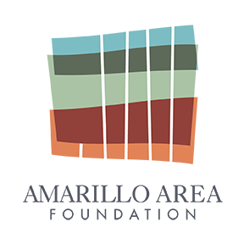

**Gold**

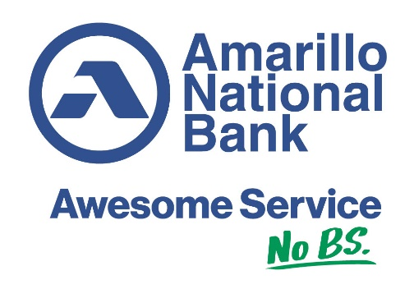



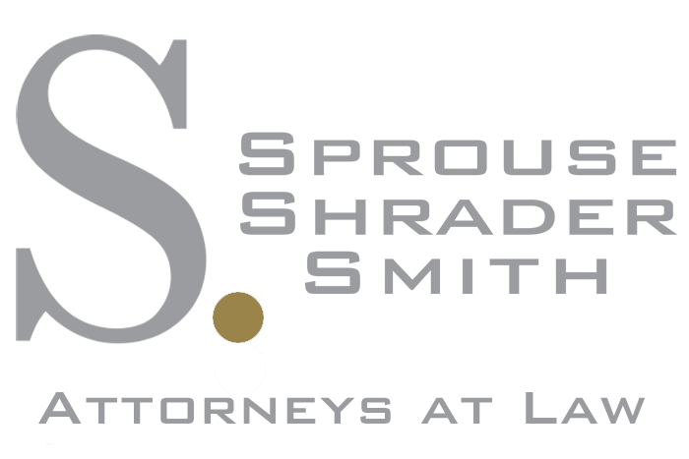

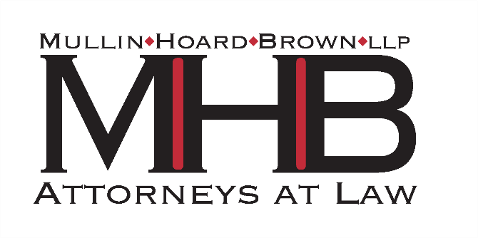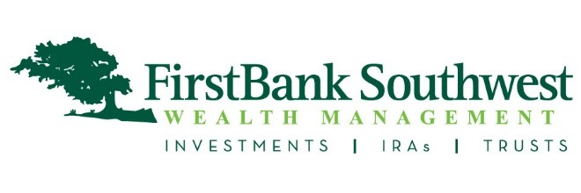**Silver**